Tutorial – 3

- Draw a real picture for class and object. Differentiate class and object in terms of diagram only.
Perform following tasks.
Task 1: Create a class
Task 2: Add few data members as private
Task 3: Add few methods as public to work on defined data members
Task 4: Create a Demo class with main method.
Task 5: Create at least two objects of a class defined in Task 1 into main method and call all methods using that object.
Task 6: Write comment for each important portion of code like data members’ declaration, methods, some important logic etc.
Task 7: Summarize above solution in your own few words to visualize the solution to the end user.

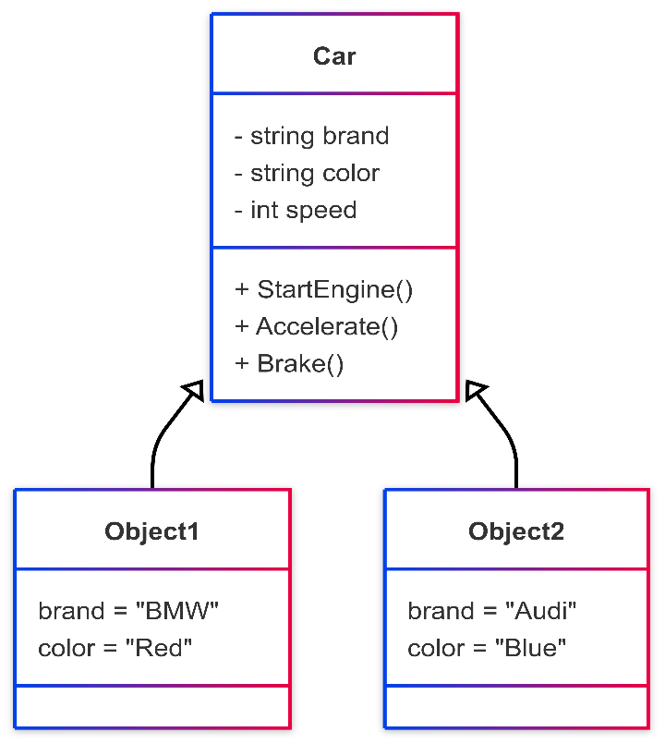

using System;
namespace Tutorial
{
class Car // Task 1: Create a class
{
// Task 2: Private Data Members
private string brand;
private string color;
private int speed;
public Car(string b, string c) // Constructor
{
brand = b;
color = c;
speed = 0;
}
// Task 3: Public Methods
public void StartEngine() // Start Engine
{
Console.WriteLine(color + " " + brand + " Car is starting.");
}

public void Accelerate(int increment) // Accelerate
{
speed = speed + increment;
Console.WriteLine(brand + " is running at " + speed + " km/h.");
}
public void Brake(int decrement) // Brake
{
speed = speed - decrement;
if (speed < 0)
{
speed = 0;
}
Console.WriteLine(brand + " slowed down to " + speed + " km/h.");
}
}
// Task 4: class with Main method
class Q1
{
static void Main(string[] args)

{
// Task 5: Create at least two objects
Car object1 = new Car("BMW", "Red");
Car object2 = new Car("Audi", "Blue");

object1.StartEngine();
object1.Accelerate(50);
object1.Brake(20);

Console.WriteLine("-----------------------------");

object2.StartEngine();
object2.Accelerate(70);
object2.Brake(40);

}
}
}

Output:

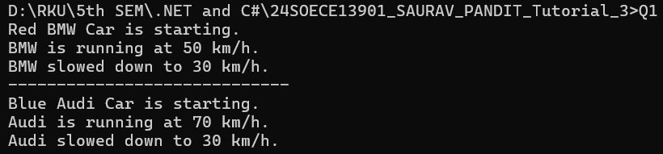

- Define a class Clock with three private integer data members hour, min and sec. Define a no argument constructor to initialize time value to 12:00:00. Define a three argument constructor to initialize the time.
Define a methods to
  - Increment time to next second.
  - Display the time value.
  - Return the hour (int getHour())
  - Return the minute (int getMinute())
  - Return the seconds (int getSeconds())
using System;
namespace Tutorial
{
class Clock
{
// Private data members
private int hour;
private int min;
private int sec;

// No-argument constructor (default time 12:00:00)
public Clock()
{
hour = 12;
min = 0;
sec = 0;
}
// Three-argument constructor
public Clock(int h, int m, int s)
{
hour = h;
min = m;
sec = s;
}
// Method to increment time by one second
public void Tick()
{
sec = sec + 1; // Increase seconds by 1
if (sec == 60)
{

sec = 0;
min = min + 1;
}
if (min == 60)
{
min = 0;
hour = hour + 1;
}
if (hour == 24)
{
hour = 0;
}
}
// Method to display current time (simple version)
public void DisplayTime()
{
Console.WriteLine("Time = " + hour + ":" + min + ":" + sec);
}
// Getter methods
public int GetHour()
{

return hour;
}
public int GetMinute()
{
return min;
}
public int GetSeconds()
{
return sec;
}
}

class Demo
{
static void Main(string[] args)
{
// Using no-argument constructor
Clock clock1 = new Clock();
Console.WriteLine("Clock1 initial time:");
clock1.DisplayTime();

clock1.Tick(); // increment by 1 second
Console.WriteLine("Clock1 after 1 tick:");
clock1.DisplayTime();
Console.WriteLine("-----------------------------");

// Using three-argument constructor
Clock clock2 = new Clock(23, 59, 58);
Console.WriteLine("Clock2 initial time:");
clock2.DisplayTime();

clock2.Tick(); // 23:59:58 → 23:59:59
clock2.DisplayTime();

clock2.Tick(); // 23:59:59 → 00:00:00
clock2.DisplayTime();

// Using getter methods
Console.WriteLine("Hour: " + clock2.GetHour());
Console.WriteLine("Minute: " + clock2.GetMinute());
Console.WriteLine("Second: " + clock2.GetSeconds());

Console.ReadLine();
}
}
}
Output :
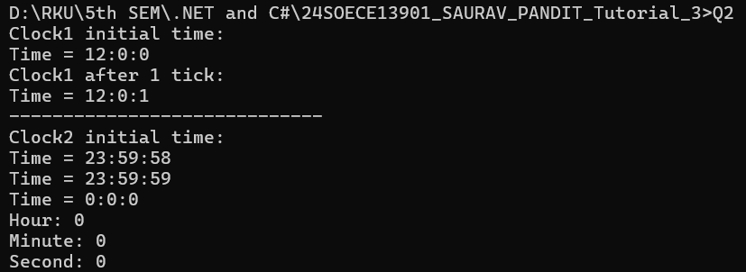

- Define a Student class with appropriate data members, property, constructors, methos etc. Define another class called TestStudent within the same .cs file. Also create an object of student class and demonstrate the use of student class.
using System;
using System.Collections.Generic;
using System.Linq;
using System.Text;
using System.Threading.Tasks;
namespace _24SOECE13901_SAURAV_PANDIT_Tutorial_3
{

// Student class
class Student
{
// Data members (private fields)
private int rollNo;
private string name;
private double marks;
// Properties (to access private fields safely)
public int RollNo
{
get { return rollNo; }
set { rollNo = value; }
}
public string Name
{
get { return name; }
set { name = value; }
}
public double Marks
{
get { return marks; }

set { marks = value; }
}
// Default constructor
public Student()
{
rollNo = 0;
name = "Unknown";
marks = 0.0;
}
// Parameterized constructor
public Student(int rollNo, string name, double marks)
{
this.rollNo = rollNo;
this.name = name;
this.marks = marks;
}
// Method to display student details
public void DisplayStudent()
{
Console.WriteLine("Roll No: " + rollNo);
Console.WriteLine("Name : " + name);

Console.WriteLine("Marks : " + marks);
}
// Method to check result
public void CheckResult()
{
if (marks >= 40)
Console.WriteLine(name + " has Passed.");
else
Console.WriteLine(name + " has Failed.");
}
}
class Q3
{
static void Main(string[] args)
{
// Using default constructor
Student s1 = new Student();
Console.WriteLine("Student 1 (Default):");
s1.DisplayStudent();
s1.CheckResult();

Console.WriteLine("--------------------------");
// Using parameterized constructor
Student s2 = new Student(101, "Saurav", 85.5);
Console.WriteLine("Student 2 (Parameterized):");
s2.DisplayStudent();
s2.CheckResult();

Console.WriteLine("--------------------------");

// Using properties to set values
Student s3 = new Student();
s3.RollNo = 102;
s3.Name = "Rahul";
s3.Marks = 32.0;

Console.WriteLine("Student 3 (Using Properties):");
s3.DisplayStudent();
s3.CheckResult();
}
}
}

Output :
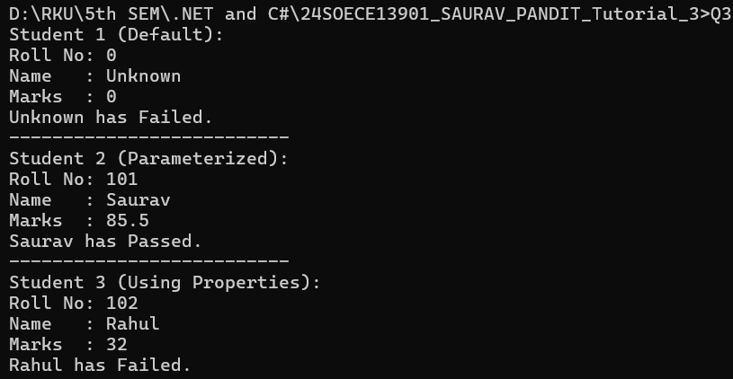

- Use above program classes and create objects for 5 students and demonstrate the use student class.
using System;
using System.Collections.Generic;
using System.Linq;
using System.Text;
using System.Threading.Tasks;
namespace _24SOECE13901_SAURAV_PANDIT_Tutorial_3
{
// Student class

class Student
{
// Data members (private fields)
private int rollNo;
private string name;
private double marks;
// Properties (to access private fields safely)
public int RollNo
{
get { return rollNo; }
set { rollNo = value; }
}
public string Name
{
get { return name; }
set { name = value; }
}
public double Marks
{
get { return marks; }
set { marks = value; }

}
// Default constructor
public Student()
{
rollNo = 0;
name = "Unknown";
marks = 0.0;
}
// Parameterized constructor
public Student(int rollNo, string name, double marks)
{
this.rollNo = rollNo;
this.name = name;
this.marks = marks;
}
// Method to display student details
public void DisplayStudent()
{
Console.WriteLine("Roll No: " + rollNo);
Console.WriteLine("Name : " + name);
Console.WriteLine("Marks : " + marks);

}
// Method to check result
public void CheckResult()
{
if (marks >= 40)
Console.WriteLine(name + " has Passed.");
else
Console.WriteLine(name + " has Failed.");
}
}

class Q3
{
static void Main(string[] args)
{
// Using default constructor
Student s1 = new Student();
Console.WriteLine("Student 1 (Default):");
s1.DisplayStudent();
s1.CheckResult();

Console.WriteLine("--------------------------");
// Using parameterized constructor
Student s2 = new Student(101, "Saurav", 85.5);
Console.WriteLine("Student 2 (Parameterized):");
s2.DisplayStudent();
s2.CheckResult();

Console.WriteLine("--------------------------");

// Using properties to set values
Student s3 = new Student();
s3.RollNo = 102;
s3.Name = "Rahul";
s3.Marks = 32.0;

Console.WriteLine("Student 3 (Using Properties):");
s3.DisplayStudent();
s3.CheckResult();

Console.WriteLine("--------------------------");

// Student 4 (Parameterized constructor)
Student s4 = new Student(103, "Anita", 67.5);
Console.WriteLine("Student 4:");
s4.DisplayStudent();
s4.CheckResult();

Console.WriteLine("--------------------------");

// Student 5 (Using properties)
Student s5 = new Student();
s5.RollNo = 104;
s5.Name = "Vikas";
s5.Marks = 45.0;
Console.WriteLine("Student 5:");
s5.DisplayStudent();
s5.CheckResult();

}
}
}

Output :
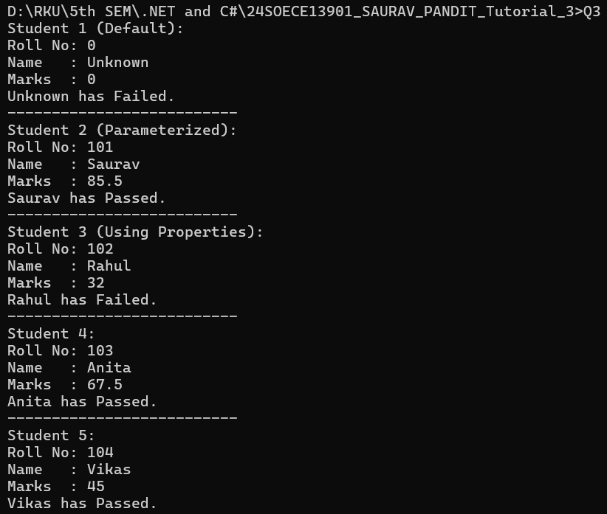

- Rearrange the given code to get the desired output.
using System;
using System.Collections.Generic;
using System.Linq;

using System.Text;
using System.Threading.Tasks;
namespace _24SOECE13901_SAURAV_PANDIT_Tutorial_3
{
class Product
{
// Data members
private string pcode;
private string pname;
private string mname;
// Constructor
public Product(string pcd, string pnm, string mnm)
{
pcode = pcd;
pname = pnm;
mname = mnm;
}
// Display method
public void Display()
{
Console.WriteLine("\nProduct Code:= " + pcode);

Console.WriteLine("Product Name:= " + pname);
Console.WriteLine("Manufacturer Name:= " + mname);
}
}
internal class Q5
{
public static void Main(string[] args)
{
int n = args.Length;

if (n < 3)
{
Console.WriteLine("Syntax Error\n");
Console.WriteLine("Must Have THREE Arguments\n");
Console.WriteLine("Please, Write as [csc TestProduct ProductCode ProductName Manufacturer] \n");
}
else
{
// Take input from command-line arguments
string pcd = args[0];

string pnm = args[1];
string mnm = args[2];
// Create Product object
Product p = new Product(pcd, pnm, mnm);
// Display product details
p.Display();
Console.ReadLine();
}
}
}
}
Output :
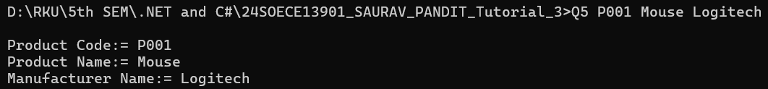
- Complete the following code that will generate the given output:
using System;
using System.Collections.Generic;
using System.Linq;
using System.Text;
using System.Threading.Tasks;

namespace _24SOECE13901_SAURAV_PANDIT_Tutorial_3
{
class Line
{
private double length; // Length of a line
// Constructor
public Line()
{
length = 10; // Missing statement-1: initialize length
Console.WriteLine("Object is being created, length = " + length); // Missing statement-2
}
// Set length
public void setLength(double len)
{
length = len; // Missing statement-3
}
// Get length
public double getLength()
{
return length; // Missing statement-4
}

}
internal class Q6
{
static void Main(string[] args)
{
Line line = new Line(); // Object creation
// First display (default length 10)
Console.WriteLine("Length of line : {0}", line.getLength());

// Set new length
line.setLength(6);
// Second display (updated length 6)
Console.WriteLine("Length of line : {0}", line.getLength());
Console.ReadKey();
}
}
}
Output :
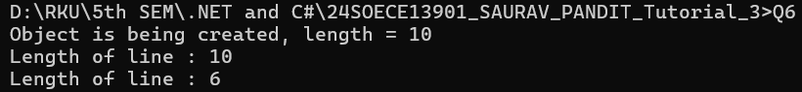

- Define EnrolmentNo and Name properties for the Student class and demonstrate use of these properties along with required data members, methods and constructors.
using System;
using System.Collections.Generic;
using System.Linq;
using System.Text;
using System.Threading.Tasks;
namespace _24SOECE13901_SAURAV_PANDIT_Tutorial_3
{
class student
{
public int EnrolmentNo;
public string Name;
// Parameterized constructor
public student(int enrolmentNo, string name)
{
EnrolmentNo = enrolmentNo;
Name = name;
}
public void Display()
{

Console.WriteLine("Enrolment No: " + EnrolmentNo);
Console.WriteLine("Name : " + Name);
}
}
internal class Q7
{
static void Main(string[] args)
{
student s1 = new student(101, "Saurav");
student s2 = new student(102, "Rahul");
s1.Display();
Console.WriteLine("--------------------------");
s2.Display();
}
}
}
Output :
